Parametric ALU + Flags + Self-Checking Testbench

Platform: WSL2 Ubuntu + Icarus Verilog + GTKWave

Abstract
This project implements and verifies a parameterized Arithmetic Logic Unit (ALU) using a clean, reproducible verification methodology. The ALU supports ADD, SUB, AND, OR, XOR, SHL, and SHR operations and produces four standard status flags: Zero (Z), Negative (N), Carry (C), and Overflow (V).
A fully self-checking SystemVerilog testbench is developed using an internal golden reference model. Directed and randomized test vectors are applied, and correctness is determined automatically without manual waveform inspection. Simulation logs and VCD waveforms provide verification evidence.
The objective of this lab is to demonstrate clean parametric RTL design, precise flag definitions, and disciplined self-checking verification using Icarus Verilog and GTKWave.

1. Project Aim
Build a reusable, parameterized ALU (width-configurable) with standard status flags (Z/N/C/V) and prove correctness using a fully self-checking simulation flow.
Market value: ALUs and flag logic appear in CPUs, DSP blocks, address generators, and control datapaths. This project demonstrates clean RTL style, interface discipline, and verification habits.
Personal growth value: You learn how to define an unambiguous spec (ops + flags), implement it parametrically, and validate with directed + randomized tests and a reference model.

2. Pre-Flight Knowledge

What an ALU does
An Arithmetic Logic Unit is a digital hardware block that performs basic calculations and bit operations on two input values. It is used in processors and many digital systems as the main unit that produces results like sums, differences, logical combinations, and shifted values.
The ALU receives two inputs called A and B and produces one output called Y. The exact operation it performs depends on a control value, so the same ALU hardware can perform many different functions.
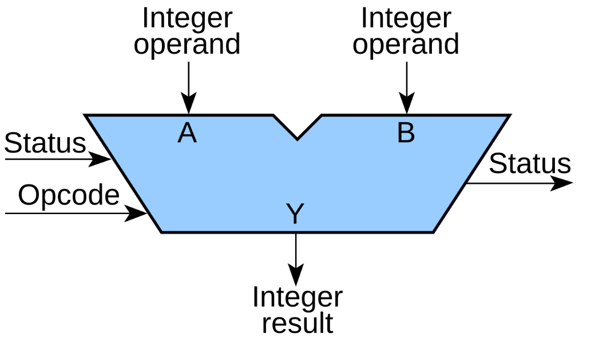
Addition: The ALU computes the sum of A and B using binary addition. If the ALU is limited to a fixed width such as 16 bits, the result is kept within that width, which means any overflow beyond the width is not kept in Y unless separate status fl ags exist.
Subtraction: The ALU computes A minus B. In most digital designs, subtraction is implemented by reusing the same adder hardware. The ALU forms the two’s complement of B and adds it to A. This approach is efficient because it avoids building a completely separate subtraction circuit.
AND: The ALU performs a bitwise AND operation, meaning it compares each bit position of A with the corresponding bit position of B. The output bit becomes 1 only when both input bits at that position are 1.
OR: The ALU performs a bitwise OR operation. The output bit becomes 1 when either A or B has a 1 at that bit position.
XOR: The ALU performs a bitwise exclusive OR operation. The output bit becomes 1 when A and B are different at that bit position, and becomes 0 when they are the same.
Shift left: The ALU shifts the bits of A to the left by a specified amount, commonly by one bit in simple ALUs. Zeros are inserted into the least significant side. This operation is often used for multiplying by powers of two in unsigned arithmetic.
Shift right: The ALU shifts the bits of A to the right by a specified amount, commonly by one bit. Zeros are inserted into the most significant side in a logical shift. This operation is often used for dividing by powers of two in unsigned arithmetic.
Opcode: An opcode is the control value that tells the ALU which operation to execute. It is a small binary code that acts like a selector.
Inside the ALU, several operation results may be computed or available through different logic paths. The opcode is decoded to select exactly one of those results as the final output Y. In a processor, the opcode often comes from the instruction being executed. In this project, the opcode is simply an input driven by the testbench to choose operations during verification.

Clocked design
A clocked design is a digital system where important signals are stored in registers, and those registers update only at specific moments defined by a clock signal. The clock is a repeating square wave that acts like a metronome. On each active clock edge, the design captures new values into its registers and moves from one stable state to the next.
Between clock edges, the registers hold their values steady. Internal combinational logic may be computing “next values” based on current register contents and current inputs, but the design does not officially change state until the next clock edge arrives and the registers latch the new values.
Why clocked design is used
● It creates predictable timing boundaries, because state changes happen only on clock edges.
● It reduces chaos and makes large designs easier to reason about, because signals are expected to be stable within a clock cycle.
● It enables pipelining, where work is split across cycles and performance can be increased by running the clock faster.
The design looks at inputs and current state during the cycle.
It computes what should happen next.
On the clock edge, it commits those new values into registers.

Reset

Reset is a control signal that forces the design into a known, safe starting condition. Digital systems power up in an unknown state because registers may contain random values at power-on. Reset solves this by clearing or initializing registers so the system begins from a predictable state.
When reset is asserted, the design sets important registers to defi ned values such as zero, idle, or a known start address. When reset is released, normal operation begins and the design starts updating on clock edges again.
● It prevents undefined behavior at startup.
● It ensures state machines start in the correct initial state.
● It makes simulation and debugging reliable, because the starting conditions are controlled.
● Two common reset styles

Synchronous reset
● The reset is applied only on a clock edge.
● The design reacts to reset at the same time it would normally update.
● This often simplifies timing analysis, because reset behaves like other synchronous signals.

Asynchronous reset
● The reset can force registers immediately, without waiting for a clock edge.
● This is useful for fast initialization and for ensuring the design can be forced into a safe state even if the clock is not running.
● It requires careful handling when releasing reset, because deasserting reset must be done safely to avoid metastability.

How clock and reset work together

A common sequence is:
● Assert reset to force all registers into a known state.
● Run the clock while reset is asserted to guarantee initialization is captured everywhere.
● Deassert reset so the design begins normal, predictable clocked operation.

Waveform

Interpreting a waveform involves examining how signals—such as clock, reset, inputs, and outputs—change over time. It helps you understand how input changes are captured on clock edges and how outputs correspond to earlier inputs based on the design’s timing.

Difference Between Combinational and Registered ALU Outputs

Combinational ALU output

In a combinational ALU, the output is purely a function of the current inputs. As soon as you change A, B, or the opcode, the logic inside the ALU starts resolving to a new result. After a small propagation delay through gates, the output settles to the correct value.
● The ALU output changes whenever any input changes.
● There is no clock involved in producing the output.
● The result is not stored inside the ALU; it is just the immediate logic result.
● If the inputs wiggle or glitch, the output can also momentarily wiggle until it stabilizes.
● In verification, you usually apply inputs, wait a short time for settling, then check the output.
● Inputs change
● A short time later the output settles
● If inputs change again, output changes again

This style is commonly used for simple blocks, learning projects, or as a sub-block inside a larger synchronous design where the output is captured by registers elsewhere.

Registered ALU output

In a registered ALU, the ALU still computes a result from A, B, and the opcode, but the output is not driven directly to the output pin. Instead, the computed result is captured into a register on a clock edge. The visible ALU output only updates at that clock edge.
● The output updates only on the active edge of the clock.
● Between clock edges, the output remains stable, even if the inputs change.
● The result is stored in fl ip-fl ops, so it is part of sequential logic.
● Reset typically forces the output register into a known value at startup.
● In verification, you apply inputs before a clock edge, then check the output after the clock edge.
● Inputs and opcode are applied
● At the next clock edge, the ALU captures the computed result
● Output changes only at that clock edge and holds steady until the next edge
This style is common in real processors and pipelined datapaths because it makes timing closure easier, supports high-frequency designs, and creates predictable cycle-by-cycle behavior.

0.2 Verification mindset

Self-Checking Testbench

A self-checking testbench is a verification testbench that determines whether the design is correct without requiring you to manually inspect waveforms or outputs.
In a traditional non-self-checking testbench, you apply inputs to the design, look at the output, and decide by hand whether the output matches what you expected. In a self-checking testbench, that decision is built into the testbench itself.
● The testbench applies a test input to the design under test.
● It also computes or looks up the expected correct output for that same input.
● It compares the expected output with the actual output produced by the design.
● If they match, the testbench records a pass for that test case.
● If they do not match, the testbench records a failure and prints enough details to reproduce and debug the issue, such as the input values, the operation selected, the expected result, and the actual result.

Advantages of Self-Checking Testbench
● You can run thousands of tests automatically and get a clear pass or fail outcome.
● Failures are immediately visible and repeatable, which speeds up debugging.
● The verification flow becomes suitable for regression testing, meaning you can rerun the same tests after making RTL changes to ensure nothing broke.
In short, a self-checking testbench is one that acts like an automated judge: it applies stimulus, checks correctness, and reports pass or fail on its own.

Reference (Golden) Model
A reference model, also called a golden model, is a trusted implementation of what the design is supposed to do. It acts as the “source of truth” for expected behavior during verifi cation.
● It is a simple, correct model of the intended functionality.
● It can be written in a convenient language such as Python, C, or SystemVerilog.
● It is usually easier to read and review than the RTL, and it avoids the same implementation tricks or optimizations used in the hardware.

Advantages

● It tells us the correct expected output for any input
When you run many tests, especially randomized tests, you need a reliable way to know what the output should be for each input and operation. The reference model computes that expected result so the testbench can compare it against the DUT output automatically.
● It enables self-checking automation
A self-checking testbench needs two things: the actual DUT output and the expected output. The reference model produces the expected output, which makes automatic pass or fail decisions possible without manual waveform inspection.
● It prevents “guessing” and reduces human error
Without a golden model, you may end up hardcoding a few expected values or manually checking waveforms. That approach misses many cases and is error-prone. A reference model makes verification consistent and scalable.
● It helps isolate bugs faster
If the DUT output mismatches the reference model, you immediately know there is a functional disagreement. The testbench can print the exact inputs, opcode, expected output, and actual output, making it easier to reproduce and debug.
● It supports regression testing and repeatability
Once the golden model exists, you can keep rerunning the same tests every time the RTL changes. This catches accidental breakages early and builds confidence that the design remains correct over time.

In this ALU project, SystemVerilog testbench then compares the ALU output against that expected result and reports pass or fail automatically.

Randomized Testing

Randomized testing means the testbench automatically generates many different valid input values and opcodes, instead of only a few hand-written test cases.
● It can find bugs that directed tests miss because:
● Directed tests cover only the cases you think of, so unusual combinations get skipped.
● Random tests explore a much larger input space and naturally hit rare patterns, overflows, underflows, and boundary values.
● With a fixed random seed, any failure can be reproduced and debugged.

Scoreboard
A scoreboard is a checking mechanism in a testbench that keeps track of what outputs are expected and then verifies the design’s real outputs against those expectations.
When the testbench applies an input to the design, it also uses a reference model to calculate the correct result. The scoreboard stores that expected result and waits for the design to produce its output. When the output arrives, the scoreboard compares expected and actual. If they match, it counts it as a pass. If they do not match, it reports a failure and prints useful details like the input values, the selected operation, the expected output, and the actual output.
This is helpful because it makes testing automatic and organized, and it still works even when the design output is delayed by one or more clock cycles.

Coverage
Coverage is a way to measure how much of the design’s behavior and input space your tests actually exercised. It answers the question: did we really test everything important, or did we just run many tests without knowing what we touched?

Hitting all opcodes means your test set includes every supported operation at least once. For your ALU, that means each opcode value was used in simulation so every operation path was exercised and checked.

Hitting corner cases means your tests included important extreme or risky input conditions that commonly expose bugs, not just random “normal” values. For a 16-bit ALU, corner cases typically include values like all zeros, all ones, maximum and minimum patterns, alternating bit patterns, and cases that cause overflow, underflow, or shifting edge behavior. When you “hit” these, it means those special cases were actually applied during simulation and verified, rather than being assumed.

1. Platform Choice

WSL2 Ubuntu + VS Code Remote was chosen because it provides:
● Linux tool reliability
● Easy installation via apt
● Seamless editing through Windows VS Code

2. Environment Setup

2.1 System Configuration

Operating System: Windows with WSL2 Linux Distribution: Ubuntu (via Microsoft Store) Editor: Visual Studio Code with Remote-WSL

● Go to Start, then search “Turn Windows features on or off”.
● Enable: Windows Subsystem for Linux and Virtual Machine Platform.

Windows Features showing WSL enabled:

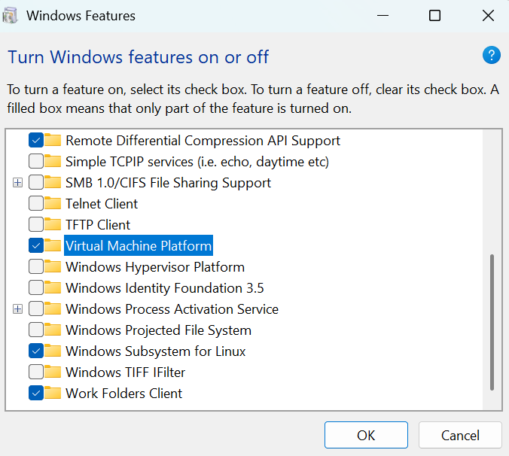

● Restart when prompted.

2.2 Install Ubuntu from Microsoft Store + create Linux username/password

In Microsoft Store search for Ubuntu and Install.
Launch Ubuntu → create a UNIX username and password (this is your Linux login).
This login is only for WSL Ubuntu, not your Windows account.
Username prompt:

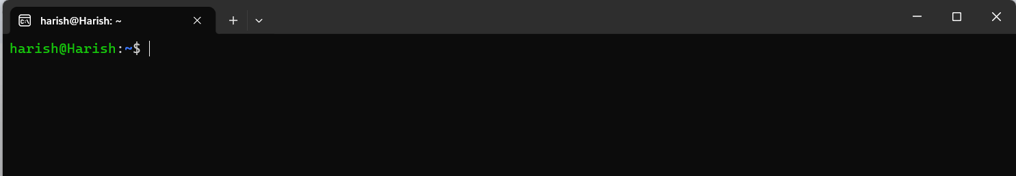
2.3 VS Code Remote - WSL
● Install VS Code on Windows.
● In VS Code go to “Extensions” here install “Remote - WSL”.
● Open Ubuntu terminal → run: .
code .
VS Code showing “WSL: Ubuntu” badge:
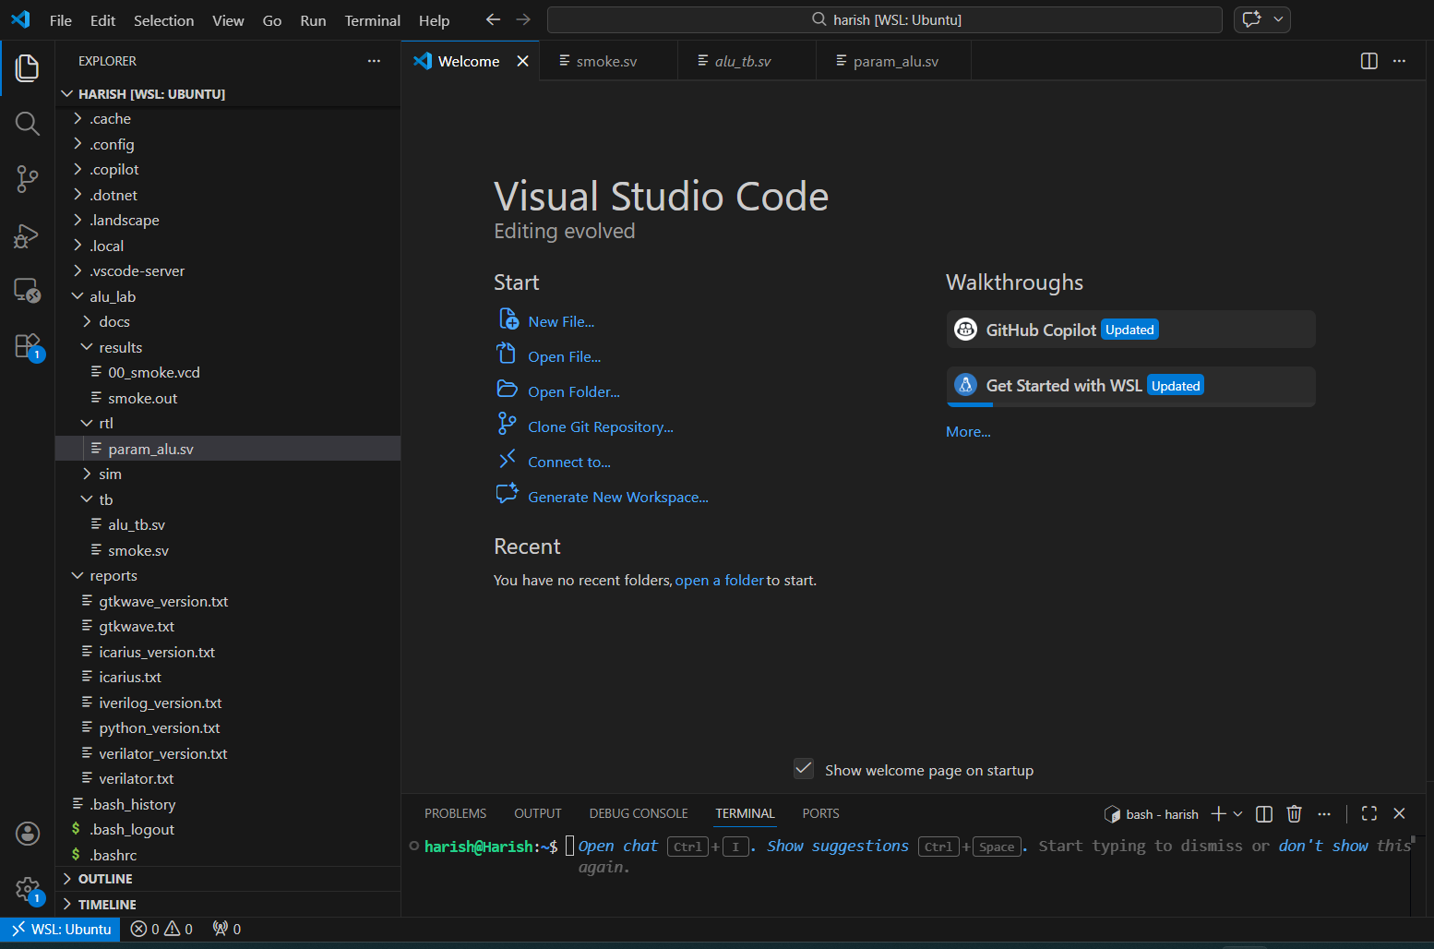

3. Tool Installation
The following tools were installed inside WSL:
● Verilator – RTL simulation
● GTKWave – waveform viewing
● Python 3 – vector generation and golden model
● Make / g++ – build support
Version information was captured for documentation.

3.1 Update packages
Run sudo apt update in linux
Ensures package lists are current.
Successful apt update :
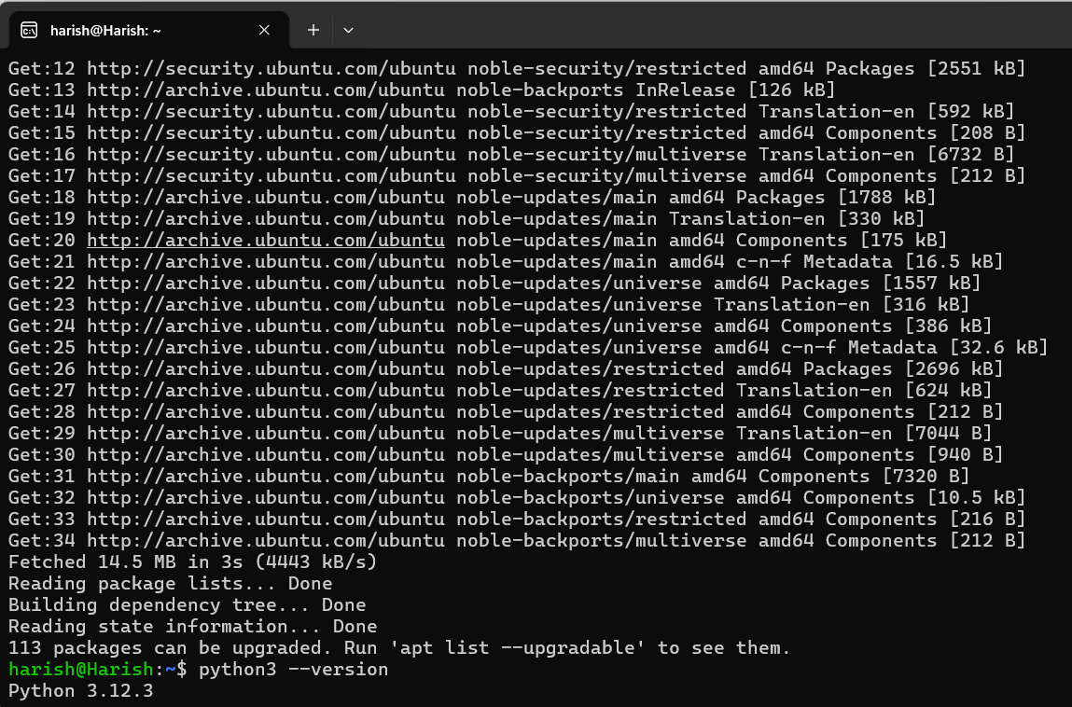
3.2 Explanation of choice

Verilator compiles Verilog or SystemVerilog into fast C++ simulation
Verilator does not run your RTL directly like many classic simulators. Instead, it translates your hardware description into equivalent C++ code that behaves the same way as the RTL logic. Then that C++ is compiled into a native executable on your machine. Because the result is compiled machine code, it can run very quickly, which is especially useful when you want to run lots of tests, long simulations, or many random seeds. In practice, this means you can iterate faster, catch bugs earlier, and run regressions without waiting forever.

GTKWave views waveforms such as VCD or FST so beginners can see what happened
When you simulate a design, you can dump signal values over time into a waveform file. VCD and FST are common formats for storing those time based signal transitions. GTKWave is a viewer that opens those files and shows signals on a timeline, so you can literally see when inputs changed, when internal signals responded, and when outputs became valid. This is powerful for debugging because you can trace cause and effect visually, zoom into a specific time window, measure delays in clock cycles, and confirm whether reset, enables, and state transitions happened in the right order.

4. Project Workspace

A structured workspace was created to keep RTL, tests, vectors, logs, and documentation separate.
VS Code Explorer showing project tree:
mkdir -p ALU_RandTB/{rtl,tb,sim,docs,reports,screenshots}
cd ALU_RandTB

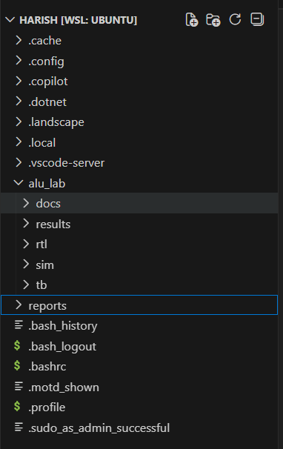

5.What an ALU Does
Design Under Test (DUT): ALU
5.1 ALU Description-Why this ALU is combinational in this project
A combinational ALU is chosen so verification is easier to understand at a beginner level. Since there is no clocked behavior or pipeline delay, the output settles directly based on the current inputs. This makes expected versus actual comparison straightforward because the testbench does not need to track cycle latency or store expected values for later checking.
How opcode-based control works here
The opcode input selects which operation the ALU performs. Each opcode value maps to exactly one operation. This structure is ideal for learning verification because it is easy to measure whether the test set exercised every operation. A good testbench should ensure every opcode value is applied multiple times with different operand values.
An ALU performs arithmetic and logical operations on two inputs A and B, selected by an opcode.
Supported operations in this project:
Opcode | Operation
000 | ADD
001 | SUB
010 | AND
011 | OR
100 | XOR
101 | SHL
110 | SHR
The ALU is purely combinational.

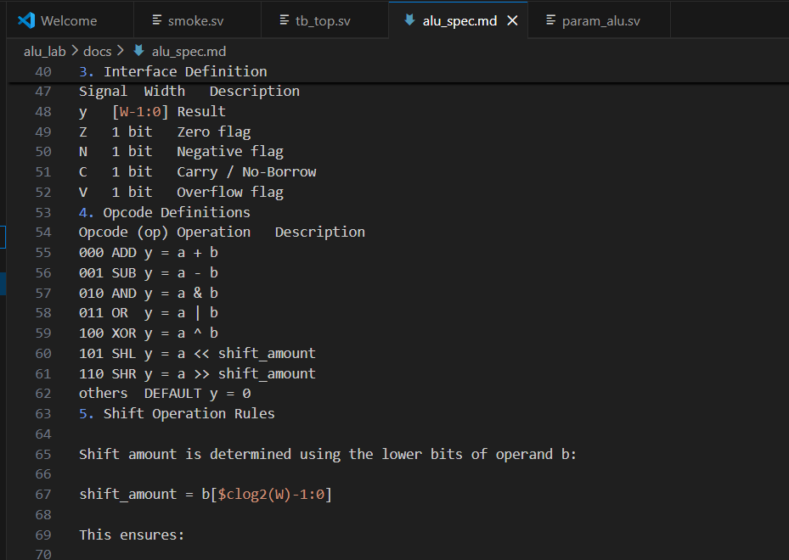

5.2 Combinational vs Registered ALU
This project uses a combinational ALU.
Combinational:
- Output updates immediately after input change
- No clock
- Output valid after propagation delay
Registered:
- Output updates only on clock edge
- Requires latency tracking in testbench
In this lab, output validity is determined by waiting #1 delay before checking.

6. Flag Definitions (Precise Spec)

Z Flag
Z = 1 when result == 0

N Flag
N = result[W-1]

Carry (C)
For ADD:
C = carry-out of MSB
For SUB:
C = 1 means no borrow
C = 0 means borrow occurred
(We use carry-out-as-not-borrow convention.)

Overflow (V)
Signed ADD overflow:
V = (~(a[MSB] ^ b[MSB])) & (result[MSB] ^ a[MSB])
Signed SUB overflow:
V = (a[MSB] ^ b[MSB]) & (result[MSB] ^ a[MSB])

Sanity Check Answers
Why can carry=1 while overflow=0?
Example:
0xFF + 0x01 = 0x00
Carry=1 (unsigned overflow)
Overflow=0 (signed result valid)
Are we using borrow flag?
No. We use carry-out-as-not-borrow convention.
smoke.sv test for checking the environment
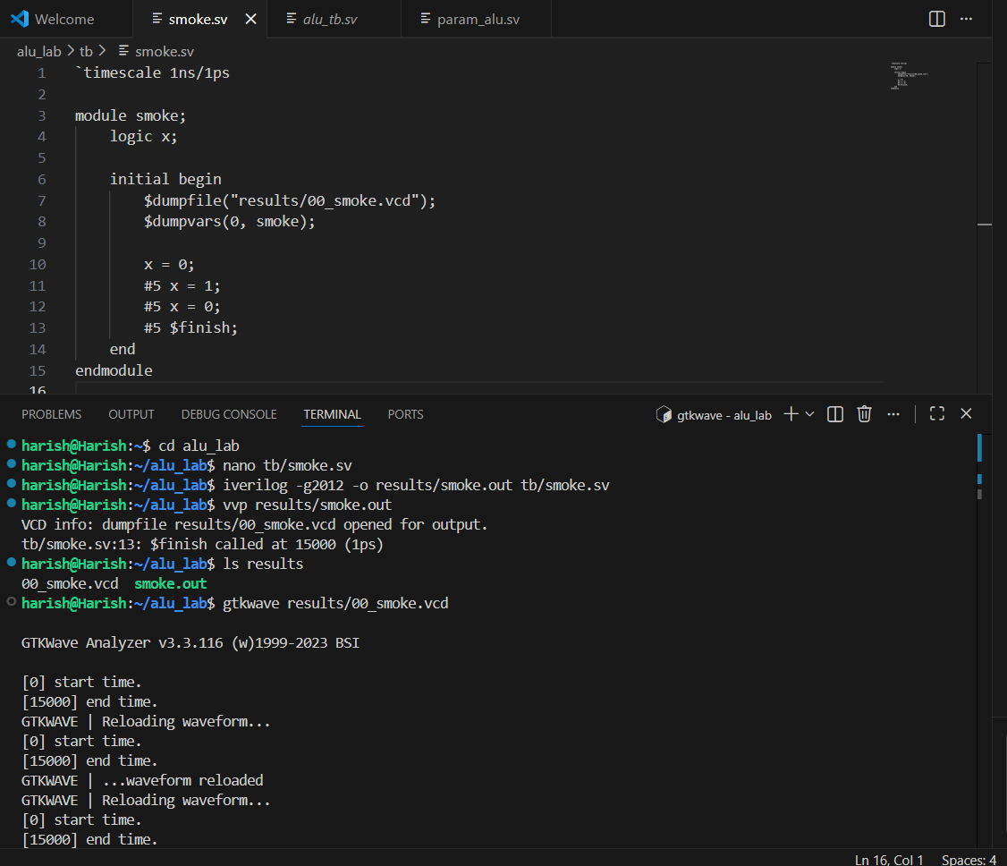
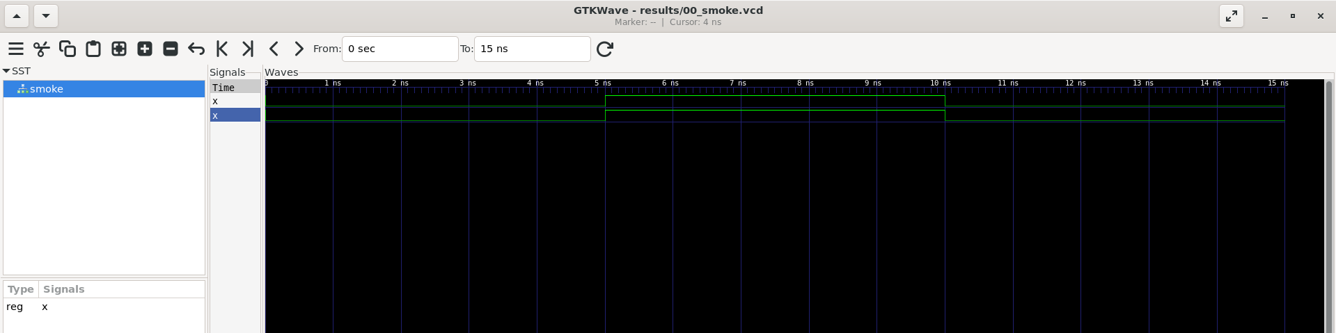

7. Parametric RTL Design

7.1 Interface (param_alu.sv)
parameter int W = 8;
input logic [W-1:0] a, b;
input logic [2:0] op;
output logic [W-1:0] y;
output logic Z, N, C, V;
All data signals scale with W.
4.2 Working RTL
module param_alu #(
parameter int W = 8
)(
input logic [W-1:0] a,
input logic [W-1:0] b,
input logic [2:0] op,
output logic [W-1:0] y,
output logic Z,
output logic N,
output logic C,
output logic V
);

logic [W:0] sum_ext;
logic [W:0] sub_ext;

always_comb begin
// defaults
y = '0;
C = 1'b0;
V = 1'b0;

case (op)
3'b000: begin // ADD
sum_ext = {1'b0, a} + {1'b0, b};
y = sum_ext[W-1:0];
C = sum_ext[W];
V = (~(a[W-1] ^ b[W-1])) & (y[W-1] ^ a[W-1]);
end

3'b001: begin // SUB
sub_ext = {1'b0, a} - {1'b0, b};
y = sub_ext[W-1:0];
C = ~sub_ext[W]; // no borrow = 1
V = (a[W-1] ^ b[W-1]) & (y[W-1] ^ a[W-1]);
end

3'b010: y = a & b;
3'b011: y = a | b;
3'b100: y = a ^ b;
3'b101: y = a << b[$clog2(W)-1:0];
3'b110: y = a >> b[$clog2(W)-1:0];

default: y = '0;
endcase

Z = (y == '0);
N = y[W-1];
end

endmodule

7.2 Design Explanation
Extended arithmetic uses W+1 bits:
sum_ext = {1'b0,a} + {1'b0,b};
This prevents truncation and preserves carry.
Flags derived from extended values ensure correctness.

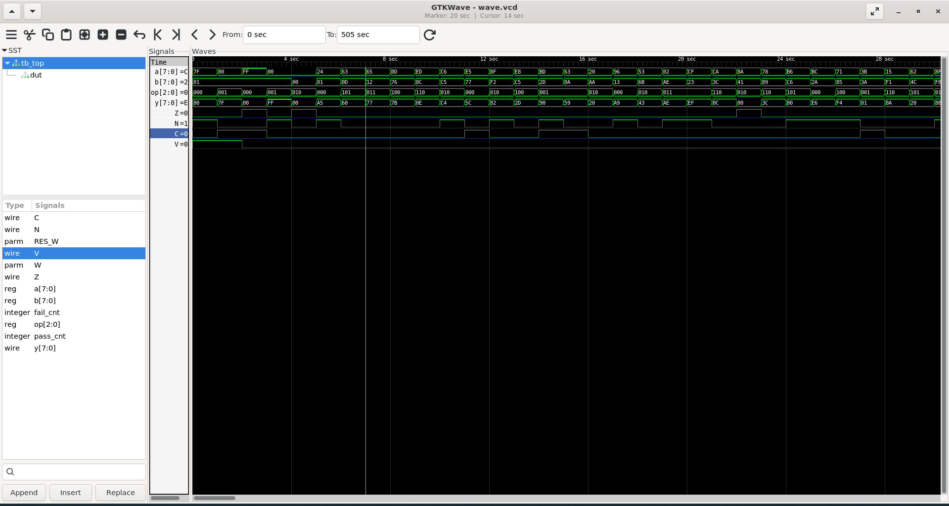

8. Reference Model
Golden model implemented inside testbench as pure function:
function automatic logic [RES_W-1:0] ref_model(...)
Important properties:
• Pure combinational
• No DUT signal access
• Follows specification, not implementation

9. Self-Checking Testbench

9.1 Methodology
Testbench flow:
- Apply inputs
- Wait #1
- Compute expected using reference model
- Compare expected vs DUT output
- Increment pass/fail counters
No manual checking required.

9.2 Testbench (tb_top.sv)
module tb_top;

localparam int W = 8;
localparam int RES_W = W + 4; // y + Z N C V

logic [W-1:0] a, b;
logic [2:0] op;
logic [W-1:0] y;
logic Z, N, C, V;

int pass_cnt = 0;
int fail_cnt = 0;

// DUT
param_alu #(W) dut (
.a(a), .b(b), .op(op),
.y(y), .Z(Z), .N(N), .C(C), .V(V)
);

// -------------------------------------------------
// Reference model (packed return)
// [RES_W-1:4] -> y
// [3] -> Z
// [2] -> N
// [1] -> C
// [0] -> V
// -------------------------------------------------
function automatic logic [RES_W-1:0] ref_model(
input logic [W-1:0] a,
input logic [W-1:0] b,
input logic [2:0] op
);
logic [W-1:0] ry;
logic rZ, rN, rC, rV;
logic [W:0] tmp;

// defaults
ry = '0;
rZ = 0; rN = 0; rC = 0; rV = 0;

case (op)
3'b000: begin // ADD
tmp = {1'b0,a} + {1'b0,b};
ry = tmp[W-1:0];
rC = tmp[W];
rV = (~(a[W-1]^b[W-1])) & (ry[W-1]^a[W-1]);
end

3'b001: begin // SUB
tmp = {1'b0,a} - {1'b0,b};
ry = tmp[W-1:0];
rC = ~tmp[W]; // no borrow
rV = (a[W-1]^b[W-1]) & (ry[W-1]^a[W-1]);
end

3'b010: ry = a & b;
3'b011: ry = a | b;
3'b100: ry = a ^ b;
3'b101: ry = a << b[$clog2(W)-1:0];
3'b110: ry = a >> b[$clog2(W)-1:0];
endcase

rZ = (ry == '0);
rN = ry[W-1];

ref_model = {ry, rZ, rN, rC, rV};
endfunction

task automatic check;
logic [RES_W-1:0] exp;
#1; // combinational settle
exp = ref_model(a,b,op);

if ({y,Z,N,C,V} !== exp) begin
$display("FAIL op=%0d a=%h b=%h | exp=%h ZNCV=%b%b%b%b got=%h %b%b%b%b",
op,a,b,
exp[RES_W-1:4],
exp[3],exp[2],exp[1],exp[0],
y,Z,N,C,V);
fail_cnt++;
end else begin
pass_cnt++;
end
endtask
initial begin
$dumpfile("wave.vcd");
$dumpvars(0, tb_top);

// Directed tests (for W=8 only)
// a=8'h7F; b=8'h01; op=3'b000; check(); // ADD overflow
// a=8'h80; b=8'h01; op=3'b001; check(); // SUB overflow
// a=8'hFF; b=8'h01; op=3'b000; check(); // carry
// a=8'h00; b=8'h01; op=3'b001; check(); // borrow
// a=8'h00; b=8'h00; op=3'b010; check(); // zero

//Directed Tests
// ADD overflow
a = (1 << (W-1)) - 1;
b = 1;
op = 3'b000;
check();

// SUB overflow
a = 1 << (W-1);
b = 1;
op = 3'b001;
check();

// ADD carry
a = {W{1'b1}};
b = 1;
op = 3'b000;
check();

// SUB borrow
a = 0;
b = 1;
op = 3'b001;
check();

// Zero case
a = 0;
b = 0;
op = 3'b010;
check();

// Random tests (reproducible)
repeat (500) begin
a = $urandom;
b = $urandom;
op = $urandom_range(0,6);
check();
end

$display("=================================");
$display("ALU TEST SUMMARY: PASS=%0d FAIL=%0d", pass_cnt, fail_cnt);
$display("=================================");

$finish;
end

endmodule

7. Directed Tests

Case | Purpose
7F + 01 | Signed overflow
80 - 01 | SUB overflow
FF + 01 | Carry
00 - 01 | Borrow
00 & 00 | Zero

10. Random Testing
repeat (500)
Random:
• a = $urandom
• b = $urandom
• op = $urandom_range(0,6)
Reproducibility:
Use fixed seed if needed.
9. Simulation Setup (Icarus)
Compile:
iverilog -g2012 -o sim.out rtl/param_alu.sv tb/tb_top.sv
Run:
vvp sim.out
Wave:
gtkwave wave.vcd
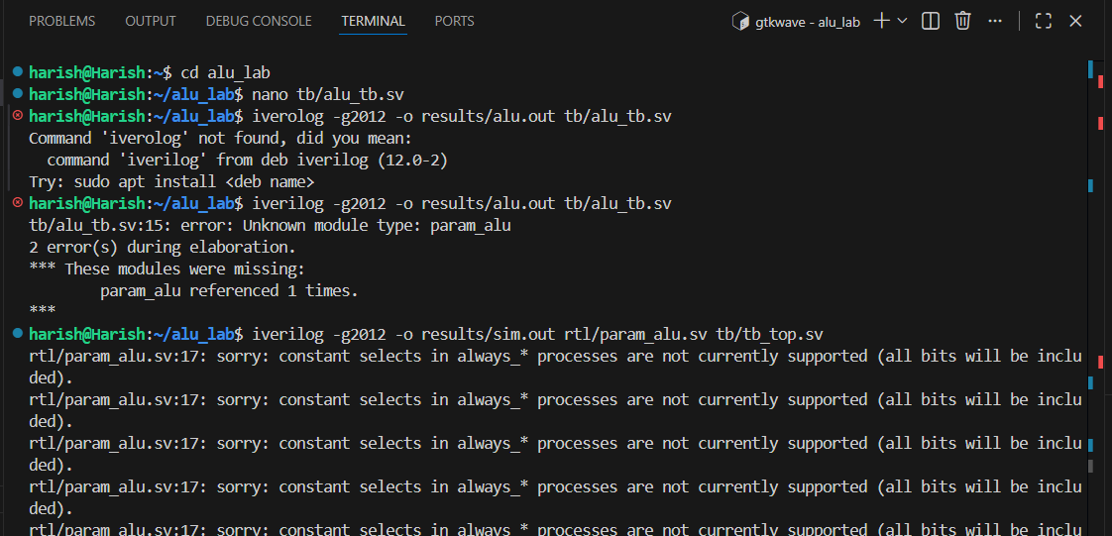
11. Simulation Results

Passing Log:
=================================
ALU TEST SUMMARY: PASS=505 FAIL=0
=================================
Scoreboard summary
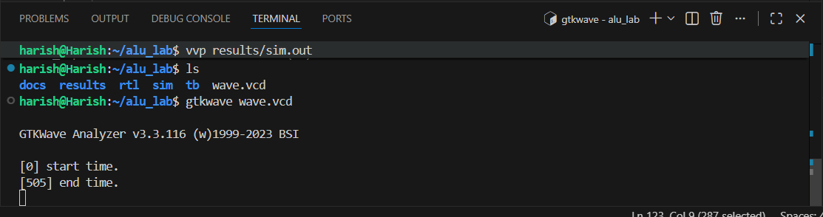

Waveform Evidence
- ADD overflow case
when,
a=7F
b=01
y=80
V=1
- SUB borrow case
when a=00
b=01
C=0
Parameter W=8
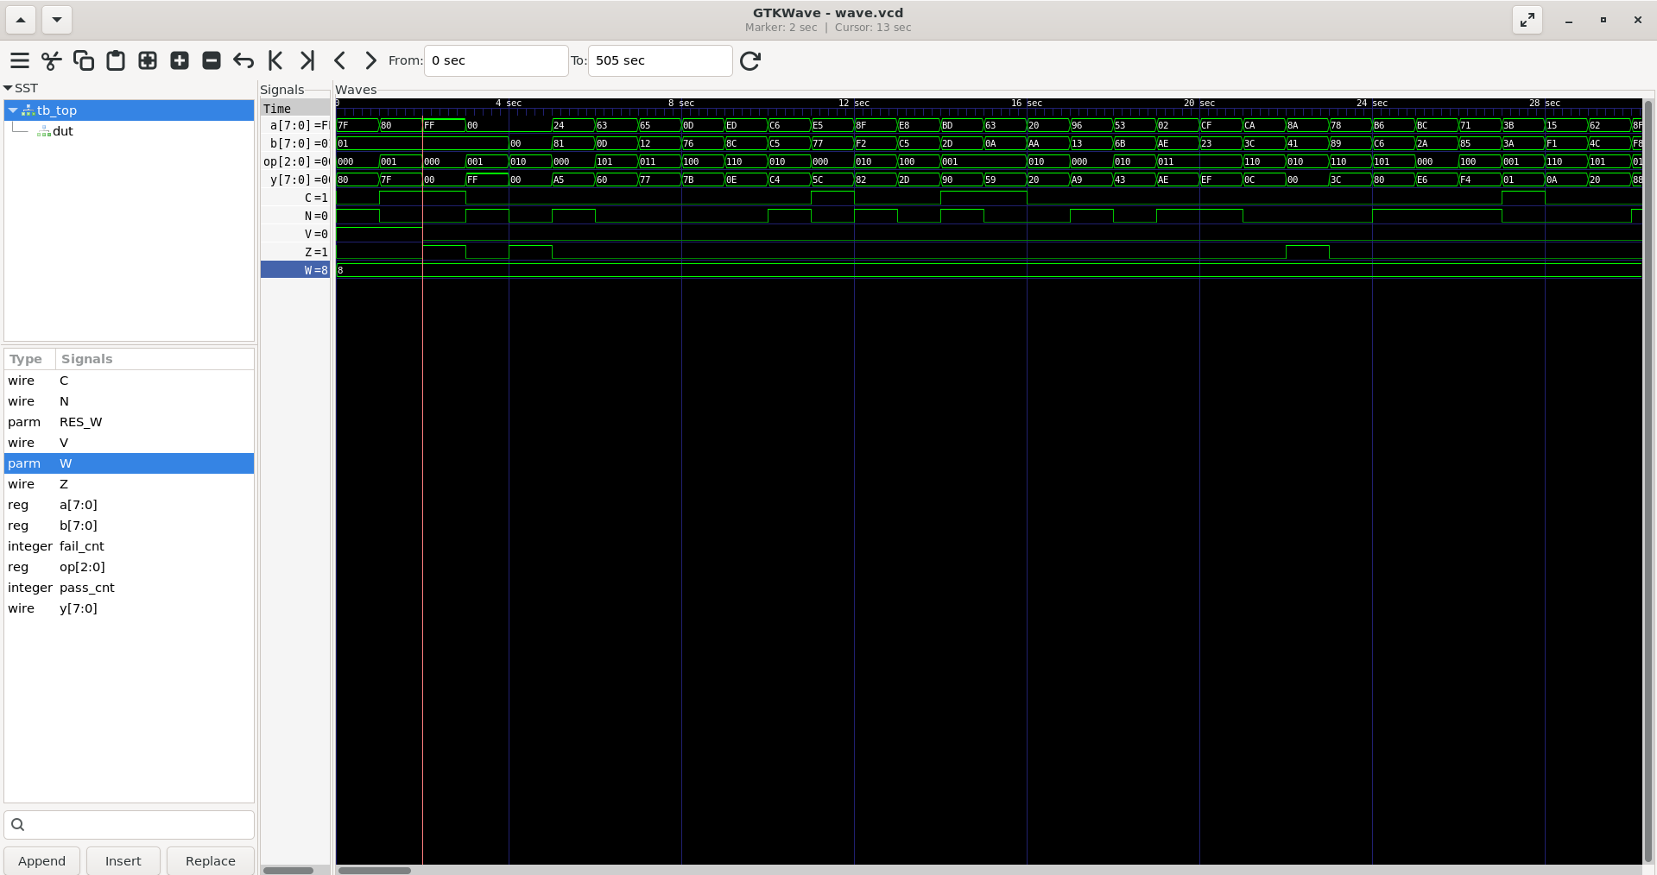

12. Multi-Width Validation
Recompiled with
W=16 (by changing localparam int W = 8; to W=16)
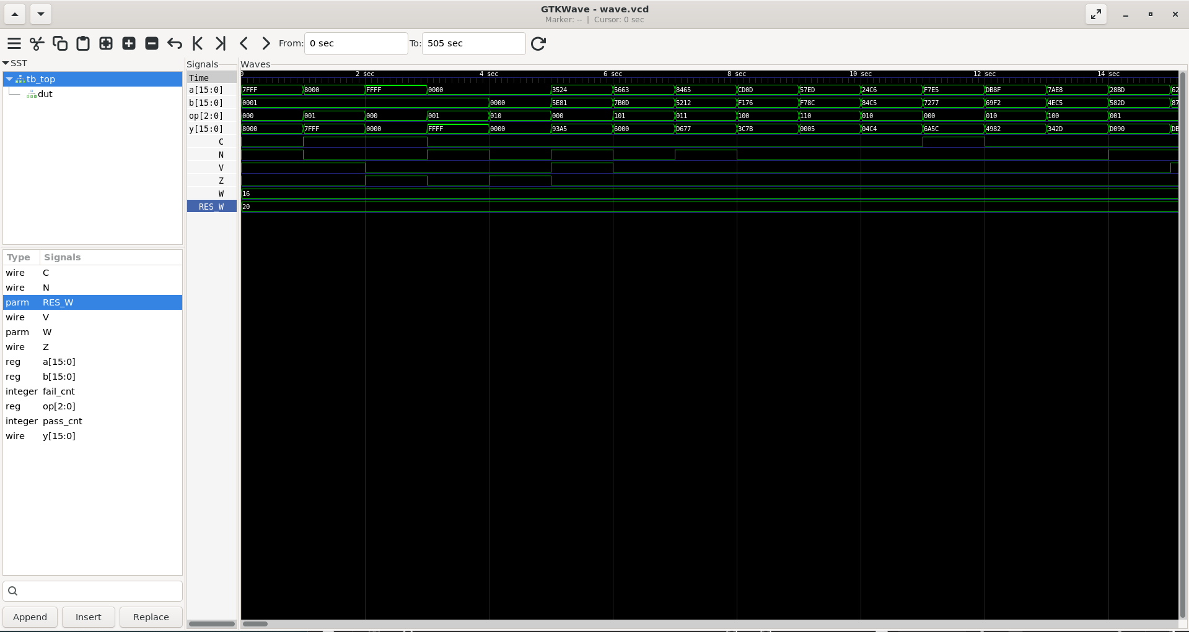

W=32 (by changing localparam int W = 8; to W=32)

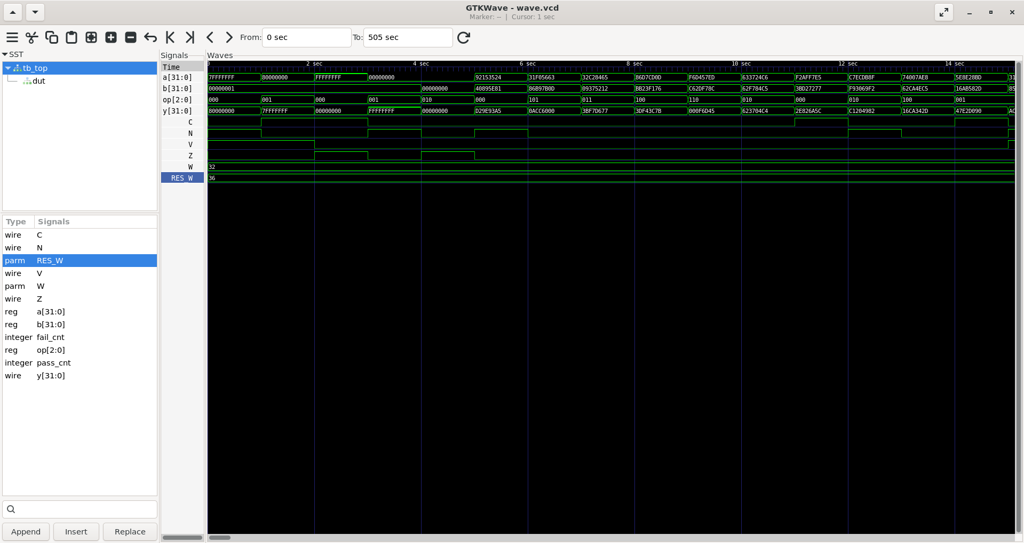

13. Reproducibility
One-command run script:
./run.sh 123
Print at end:
[SUMMARY] W=8 seed=123 ntxn=500
[SUMMARY] TOTAL_PASS=505 TOTAL_FAIL=0
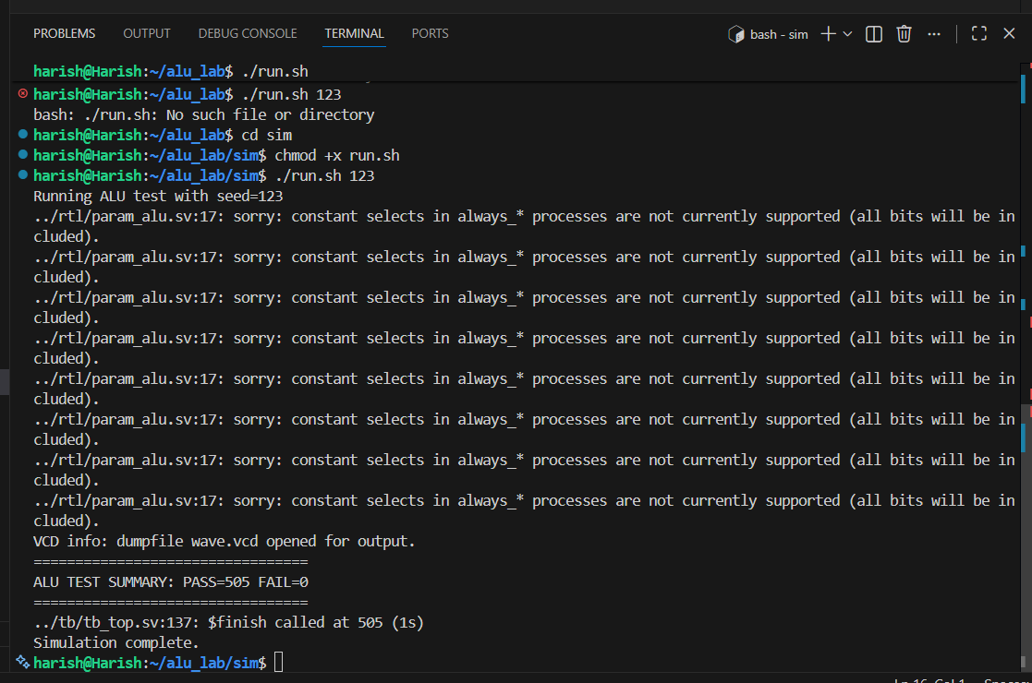

14. Self-Check Questions

Difference Between Carry and Overflow
Carry relates to unsigned overflow from MSB.
Overflow relates to signed interpretation error.
They are independent conditions.

Reproducing Random Failure
Fix seed:
void'($urandom(32'h1234));
Rerun → identical failure.
Reduce to minimal failing vector.
The script uses a user-specified seed (--seed) to control randomness. With the same seed and settings, the generated vectors will be identical every time. This is critical when a failure occurs because you can rerun the exact same stimulus and reproduce the bug consistently.

Exact Cycle Output Becomes Valid
This ALU is combinational.
Output valid in the same cycle after propagation.
Testbench samples at #1.

15. Learnings & Outcomes
• Learned to define precise flag behavior
• Learned to avoid truncation using W+1 arithmetic
• Built portable self-checking testbench
• Implemented reproducible randomized testing
• Developed debug workflow linking log + waveform

16. Evidence Checklist
Required screenshots:
- Tool versions
- Project tree
- Opcode table
- Directed cases
- Overflow waveform
- Borrow waveform
- Summary PASS
Required files:
- rtl/param_alu.sv
- tb/tb_top.sv
- run script
- transcript.log
- wave.vcd
- alu_spec.md
- RECORD_LOG.md

Conclusion
This project demonstrates clean parametric RTL design and disciplined verification methodology using reproducible, self-checking simulation flow.
The ALU implementation is width-scalable, flag-accurate, and verified using directed + randomized stimulus with complete traceability through logs and waveforms.

